**Abby Cunningham**

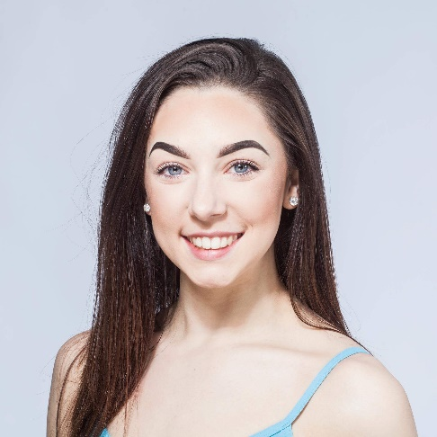

**Personal Details:**

Hair Colour: Brown

Eye Colour: Blue

Date of Birth: 9th December 1997

Nationality: British

Height: 5” 4

**Contact Details:**

Telephone: 07538954716

Email: [abbynic123@gmail.com](mailto:abbynic123@gmail.com)

Website:

**Professional Training: Qualifications:**

* Classical Ballet Ballet West HND (2014-2016)
* Pas de Deux BA Honours Dance (to be
* Pointe completed in May 2017)
* Jazz
* Commercial
* Choreography

**Professional Experience:**

January and February 2015 - Ballet West Tour Romeo and Juliet – Corps de Ballet

(Villager)

January and February 2016 – Ballet West Tour The Nutcracker – Corps de Ballet

(Candy Cane)

January and February 2017 – Ballet West Tour Swan Lake – Corps de ballet

(Waltz)

May 2015 – Ballet West Showcase – Dancer

May 2016 – Ballet West Showcase – Dancer

**References:**

**Jonathan Barton – Ballet west Vice Principal**

**Telephone:** 01866 822641

**Gillian Barton – Ballet West Principal**

**Telephone:** 01866 822641